**22Final 2240 Project Report**

The software is to be used in a marking sense. Making use of databases, the items are easily accessed into the front end of the software where users can browse all the items for sale and see what other users have to say about the products through reviews. With the digital age being upon us it is important for all businesses to have some online presence for ease of use and to boost their sales. Using our software would allow a company or any seller to help put their product out for the public to see.

In a general sense, the industry that our software specifically targets is the online computer industry where stores big or small could convert their products over to our version. While our intended target was the tech industry, the conversion to other products isn’t difficult and would make use of many of the same fields, possibly switching over some of the specifics classifications to broaden the field of use.

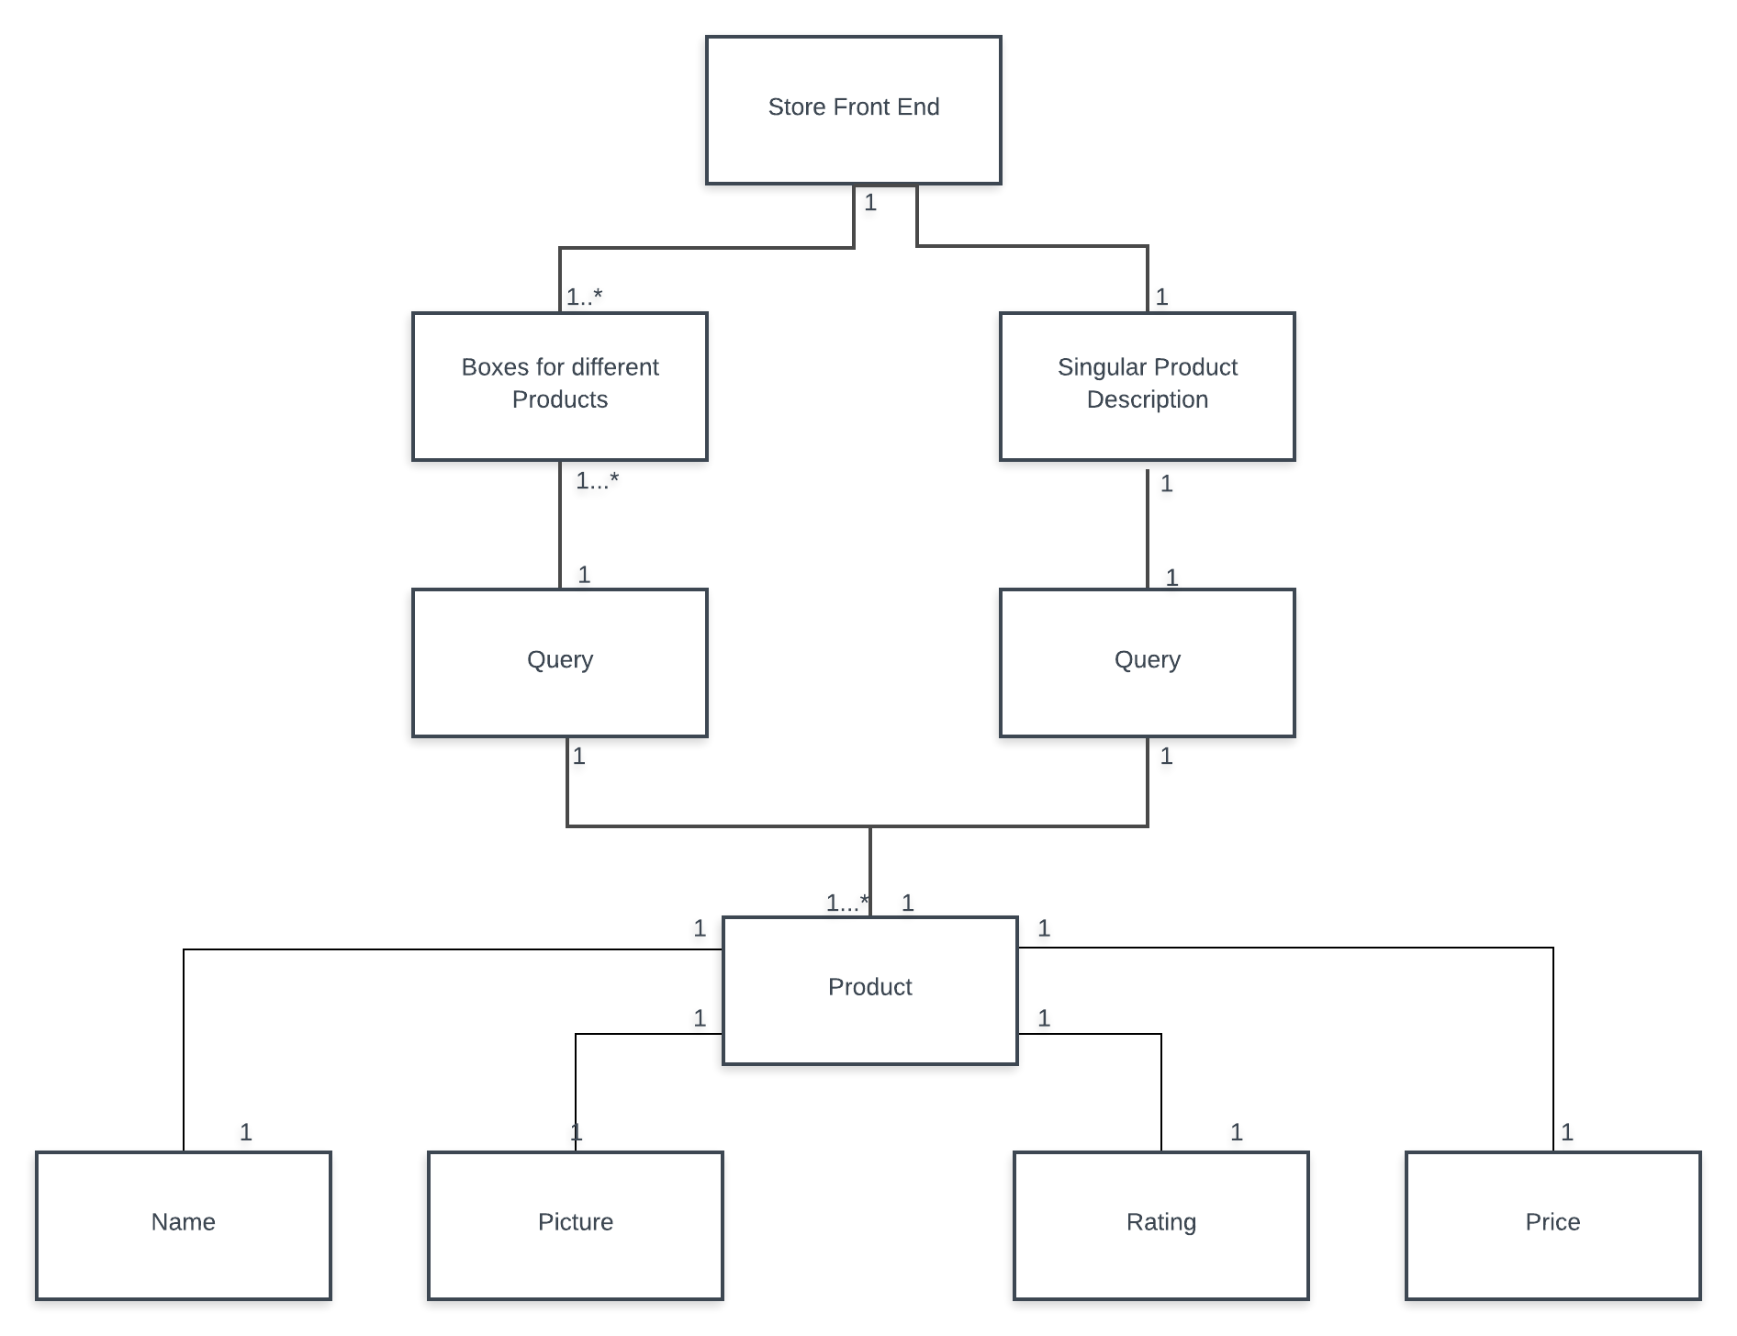As seen by this diagram the program takes the backend database and reads the data from it. The front end reads in the items from the database and places them neatly into the placeholders. Data will only be generated in two cases, either individual data or multiple queries to all the different boxes shown on the screen.

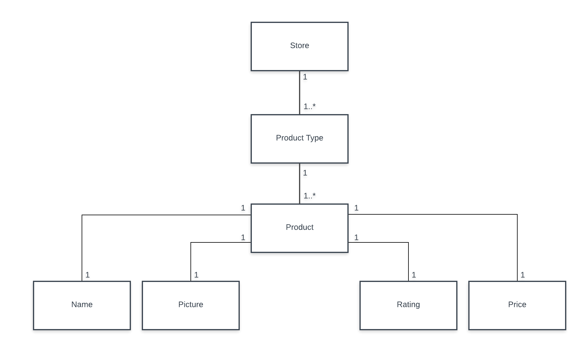

As seen in this diagram the way that the store is structured allows for at least 1 product type to exist in any 1 store. However, this also shows that there is a minimum of 1 product per product type at any one time which has its own name, picture, price, and rating to go with it.

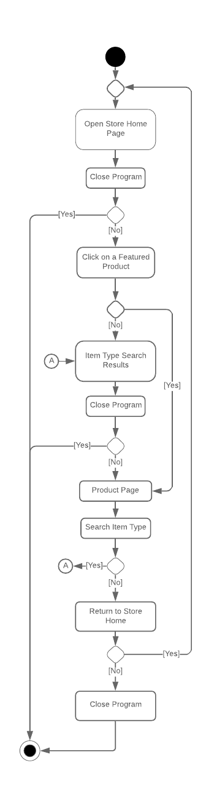

As seen in this diagram the user can travel to almost any page from the current page they are on. The only navigation that is not possible is moving from one item type search result to another item type search result. Along with this navigation, the user can quit the program whenever they like.

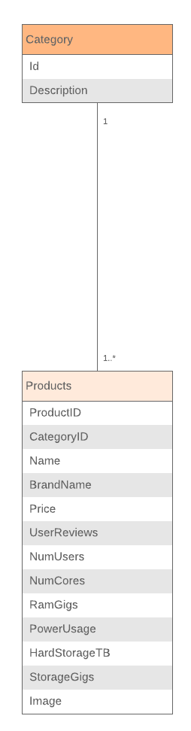

Finally, as seen by the diagram here there are two different tables in the database. The first table holds the categoryID and the descriptions and then second holds the ID for each product and all of the relevant information about the product (name, reviews etc…). Making use of SQL statements the program is able to search quickly through the database and retrieve what is needed by the front end.

The easiest thing to implement was filling the table with the data. While not an easy task, as it required understanding of how the database worked, when the base was layed out for all the different products and it was determined which products would need which specifics, the entry of data into the table was quite simple and easy.

Putting everything together and making use of java to complete the project. There have also been a fair few issues when trying to create the JavaFX program as some programming issues took quite a lot of searching online to discover a solution.

If I could go back I would have probably chosen something that involved less intertwining of different programs and platforms. Making the SQL and java work coherently was a massive pain, while making use of java solely and possibly another easier side program would have created much less work and stress for the entire project.

Through this project I learned about databases, and what position they hold in the real world. As inconvenient as they are to set up sometimes, it is incredibly useful and efficient to have all data in one location and readily accessible through the different statements.

During this project I have learned the important skills of creating a program which allows users to utilize a GUI instead of having to use the console. This is essential to real world programming as almost every program available uses a GUI to act as a buffer between user inputs and the actual program code. This also makes the program far more user friendly since the need for a console is no longer necessary.